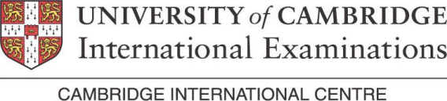

Cambridge International Certificate in
Human Resources Management



Human Resources Management is an essential need for business as it's the strategic and coherent approach to the management of an organization's most valued assets - the people working there who individually and collectively contribute to the achievement of the objectives of the business.

Certificate Content :
- Understand Human Resources Management, its development, purpose and organization
- Understand how the employment market, and the frameworks within which an organization operates, affects the management of people
- Understand how organizations plan and meet their human resources requirements
- Describe and evaluate the methods used to enable individuals and groups to work together effectively and resolve conflict
- Explain and analyze how organizations reward, motivate and develop employees.

Starting Date December 19, 2012

REGISTER NOW

